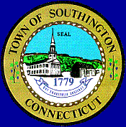
SOUTHINGTON PUBLIC SCHOOLS
PAY DATE SCHEDULE
2018 – 2019

July 6, 2018 January 4, 2019

July 20, 2018 January 18, 2019

August 3, 2018 February 1, 2019

August 17, 2018 February 15, 2019

√ August 31, 2018 March 1, 2019

September 14, 2018 March 15, 2019

September 28, 2018 March 29, 2019

October 12, 2018 April 12, 2019

October 26, 2018 April 26, 2019

November 9, 2018 May 10, 2019

November 23, 2018 May 24, 2019

December 7, 2018 June 7, 2019

December 21, 2018 June 21, 2019**

……………………………………………………………………………………………………………..

√ First Pay for Teachers, Para, Secretary 191 & 212, Nurses, ABA Therapists
** Teachers, Para Educators, Secretary 191 and 212, Nurses, ABA Therapist, 22nd pay or
Balloon Check (26 pays)

