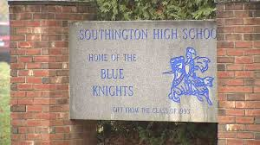
SOUTHINGTON HIGH SCHOOL NEWSLETTER

Principal’s Message December 2018
Dear Parents and Guardians,

December is here and we are preparing for the end of the first semester. The month of November brought about the end of the first marking period and the start of the second marking period. We held our annual Parent/Teachers conferences on the afternoon of November 15th. Mother Nature decided to send us an early “Winter” storm that caused us to cancel the evening portion of these conferences. We held the evening conferences on November 29th. On November 14th, we held our annual Veterans Day Concert and honored all of our Veterans with a patriotic performance performed by our outstanding Music Department. On November 16th, our annual Homecoming Dance was held in the cafeteria. More than 500 students attended and had an excellent time. The following week, SHS fans saw our Girl’s Powder Puff Football team score a victory over visiting Rocky Hill and our Boy’s Football team had an impressive win over Cheshire on the night before Thanksgiving. In addition, all our Fall Sports teams had very successful seasons. Our outstanding Marching Band finished second in the nation at Met Life Stadium in New Jersey losing the title by less than one percentage point. On November 30th, our Drama Club sponsored a “Knight on Stage.” This production was well attended and gave our student body an opportunity to have a fun filled evening as they showcased their talents.

My December Parent/Guardian update listed the schedule of events for the month. As a reminder, we will be holding a Holiday Concert on Wednesday, December 19th. The Chorus and Jazz Ensemble will perform at 6:00 pm followed by the Band and Orchestra at 7:30 pm. Winter recess will start at 12:15 pm on December 21st. We will return from the Winter break on Wednesday, January 2nd.

Best regards,

Brian Stranieri
Principal
Southington High School

  - Southington Public Schools

Vision of the Graduate

A graduate of the Southington Public Schools will be college or career ready and prepared for life beyond by mastering the knowledge and demonstrating the skills to communicate effectively, think creatively and critically, and contribute to the global community.

Ninth Grade Academy

The transition from middle school to high school, especially a high school as large as Southington High School, can be intimidating to ninth graders. Students of all academic abilities can experience difficulties with academic, social, and emotional issues. The familiar support system that students had in the middle schools is gone. As expectations for academic work and preparation outside the classroom increase, time management and organizational strategies need to be strengthened. The Ninth Grade Academy within SHS addresses these issues. Ninth grade home rooms, lockers, and most ninth grade classes are located in the east wing of the building to minimize the amount of travel to and from lockers and classrooms. One of the high school assistant principals and two school counselors are dedicated exclusively to ninth grade students. This allows these staff members the opportunity to focus on the academic progress of freshmen and to identify issues that could negatively impact their first year experience. A developmental school counseling program which focuses on student acquisition of effective strategies designed to help freshmen meet the high school’s learner expectations and to make positive adjustments to the high school is an integral part of the Ninth Grade Academy. Moreover, an SRBI Planning Team assigned to ninth grade meets weekly to review student progress.

ALTA
ALTA is an extension of Southington High School that provides students with an alternative educational setting designed to meet their needs. It is a school of choice. Students apply for acceptance into the program. Please contact any member of the Counseling Department for additional information. All ALTA students are expected to follow and adhere to the guidelines, rules, and procedures stated in the Student/Parent handbook. The handbook is found on the main page of the SHS website.
you!

To wrap up the extreme weather unit Channel 3 meteorologist Scot Haney visited the Achieve classroom. This gave students a chance to make real world connections to what they learned in science. During his visit, students presented information on the types of extreme weather that they studied. Students also asked Mr. Haney questions about his job as a meteorologist.

The Supermarket Careers & Achieve programs started a new endeavor called Knights Express aka snack cart. Studentswalk around SHS selling snacks to staff in the faculty rooms, offices etc. Knights Express will be expanding opportunities for student learning. Students will design and run a snack cart business that gives them the opportunity to develop their math, social, and vocational skills outside of the classroom.

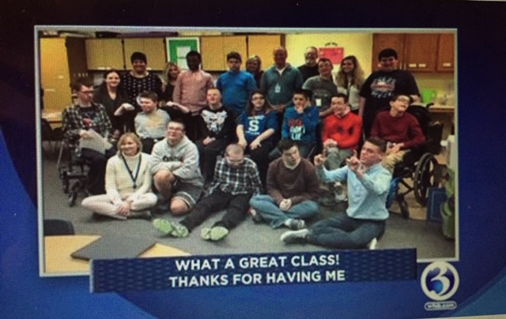

On Friday, November 9, 35 French students and three chaperones went to the Museum of Fine Arts in Boston to attend a special exhibit of their French impressionist paintings, 'French Pastels,' from the museum's permanent collection. This was followed by a three-course French luncheon at a local bistro. The students not only had the opportunity to see famous impressionist paintings rarely exhibited, but also to taste and to savour authentic French food and cuisine in a Parisian bistro setting.

The French club also hosted a Crepe and Croissant breakfast in early December. Staff and students enjoyed homemade crepes with strawberries and whipped cream in addition to coffee or tea

In November, the
Spanish club hosted a small event called, "Tertulia". It is an opportunity for students to chat with their peers in the target language without the pressure of a grade. Students came with friends, ate snacks, and used the conversation cards on the table to continue their conversations(written by World Language Honor Society). All of the students did an amazing job of speaking in only Spanish and had a great time!

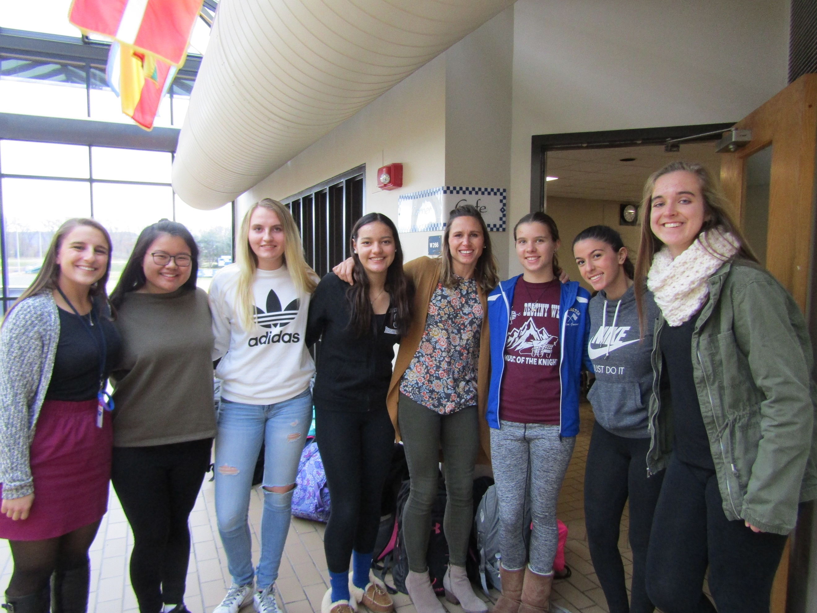

Olivia Calandra, Katy Iverson, Becca Dorzen, Jacob Gius, Abby Abrams, Liv Liberti

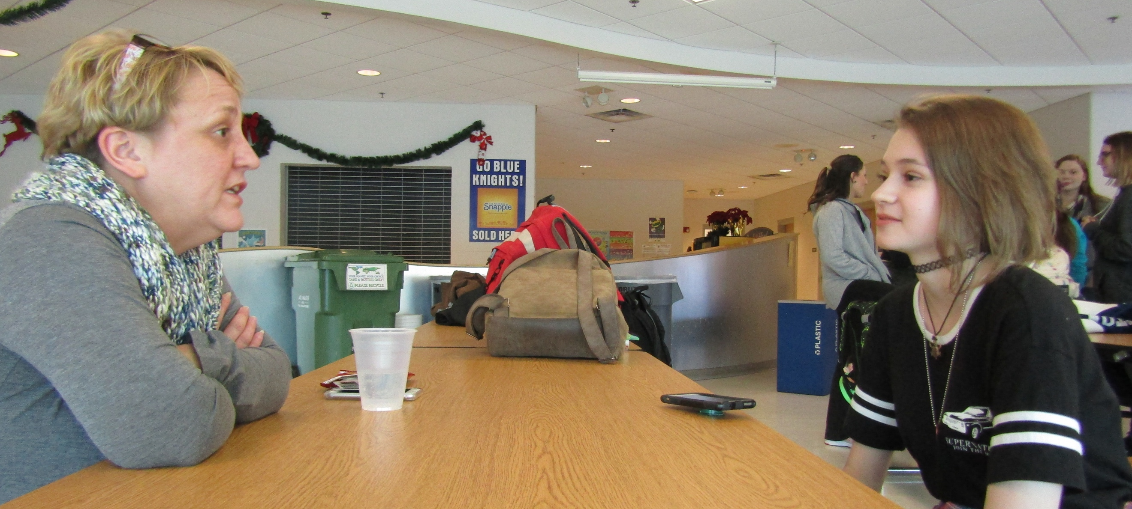
Ms. Jorgensen and Ms. Guerrin

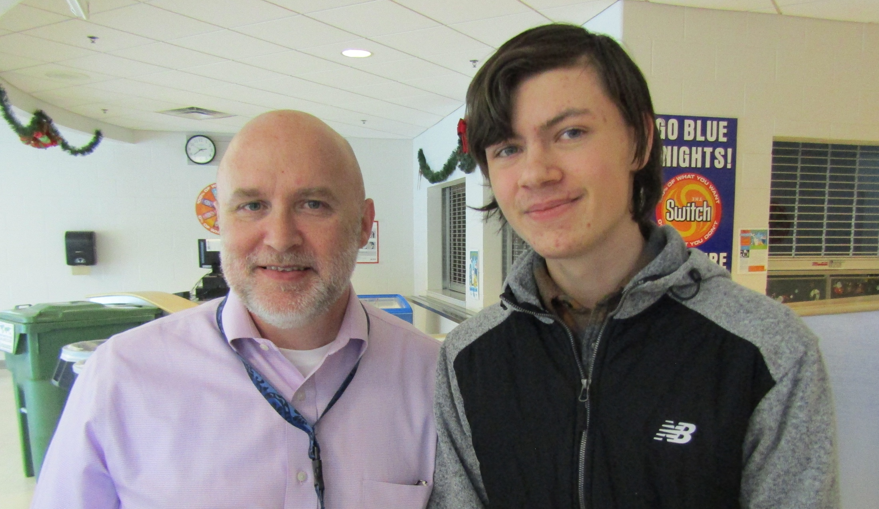
Mr. Gagnon with Patrick Bennett

On Thursday, November 29th, students in Southington High School's GSA (Gender and Sexuality Alliance) hosted a teacher & staff appreciation meeting. The club provided refreshments for teachers and staff as a way of thanking them for all their hard work and in particular for the support they provide to LGBT+ students at SHS.

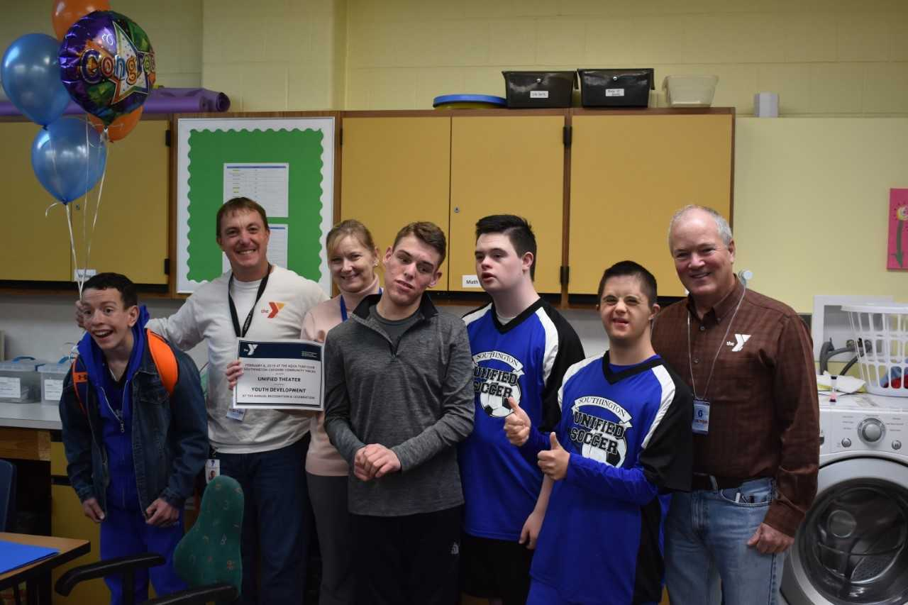
Margaruite Maddelena, Unified Sports Advisor
Karen Cavanaugh, Mark Pooler and John Myers with the kids from the DECA mart.

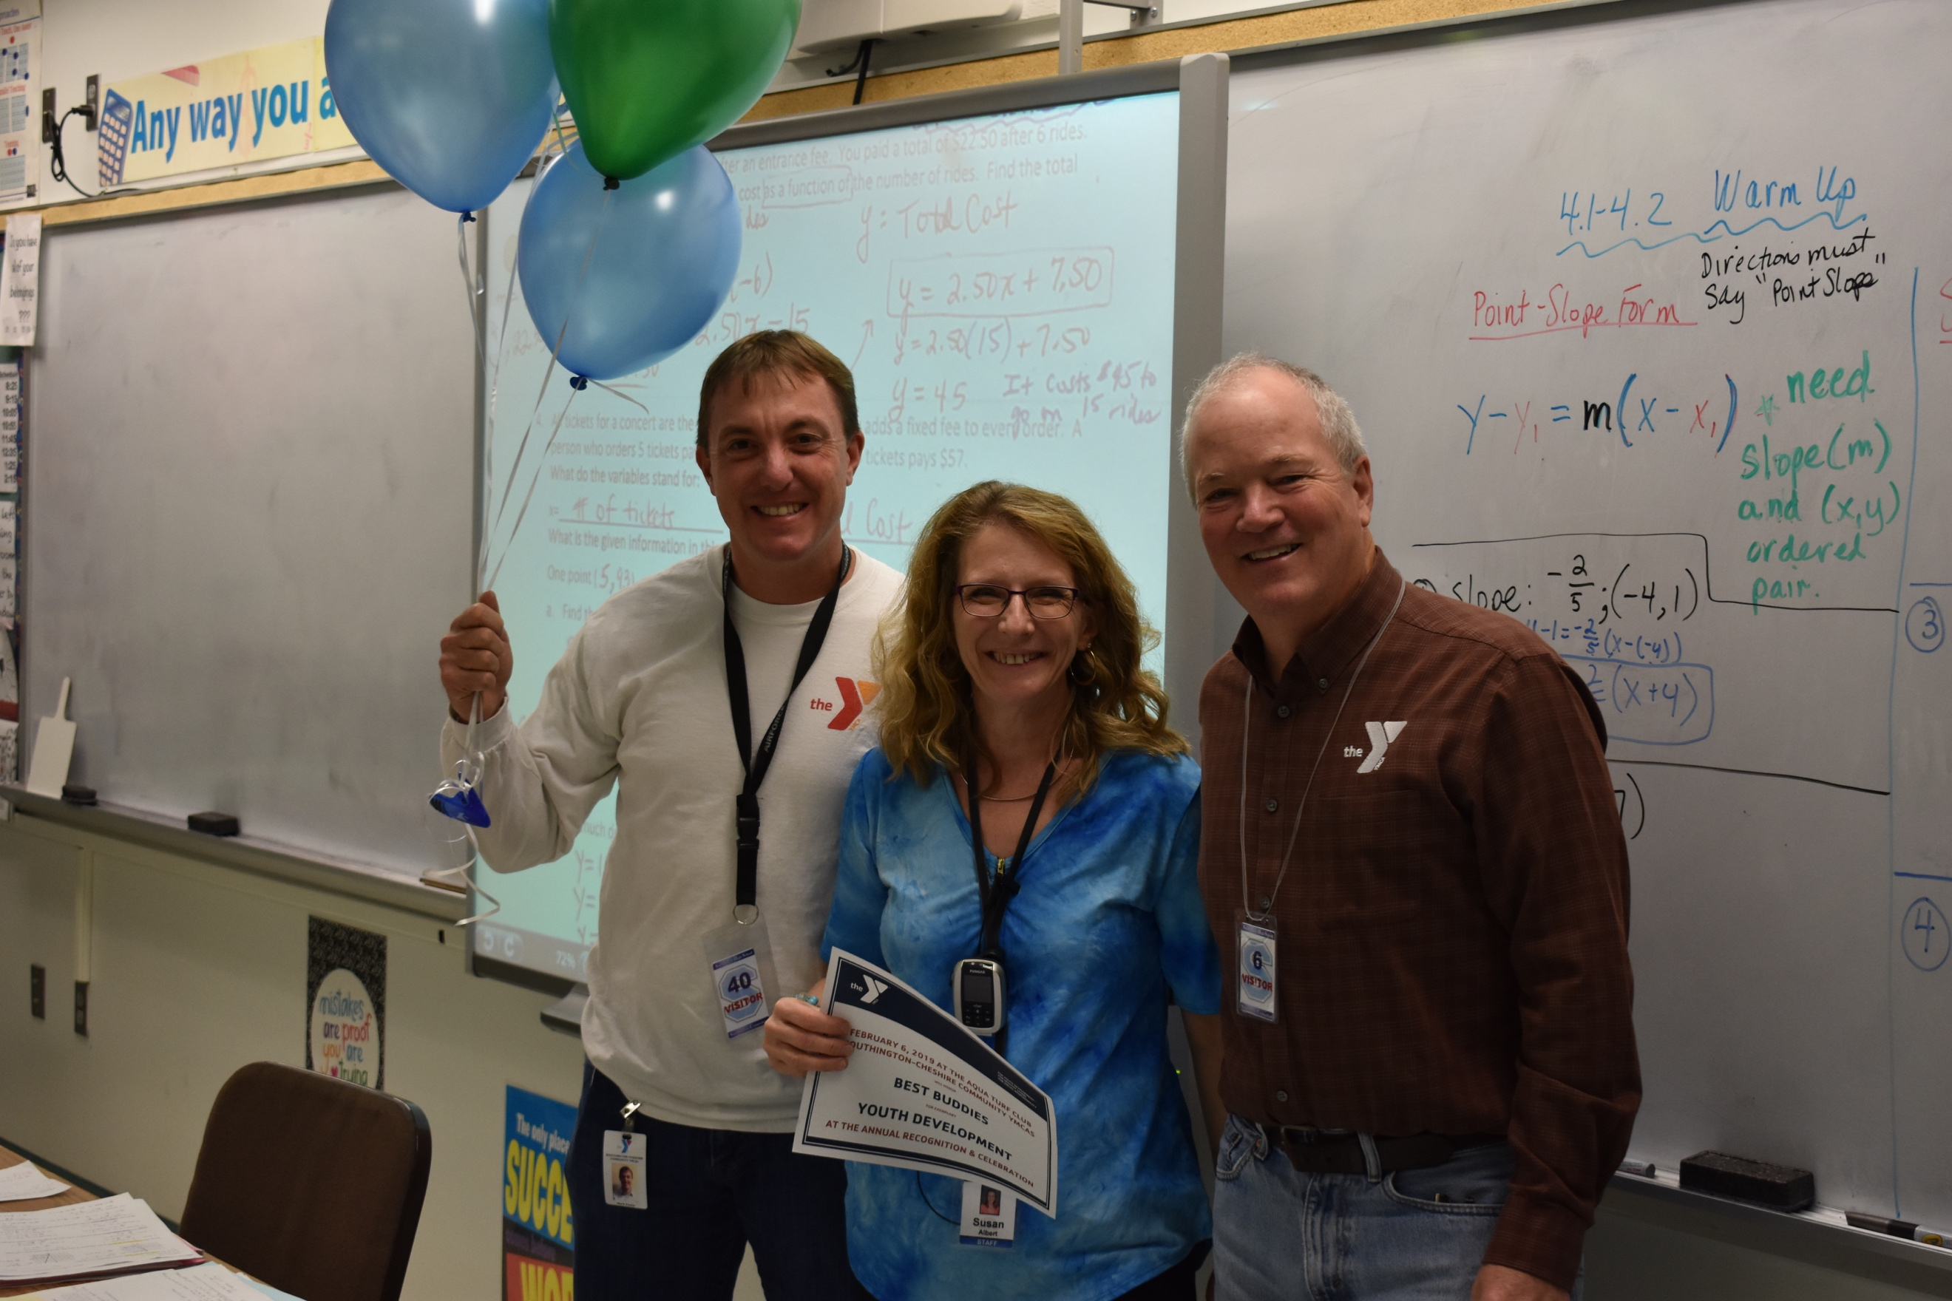

Recently, three teachers were honored by the YMCA for their contributions to student organizations. John Myers, Executive Director of the Southington YMCA and Mark Pooler, incoming Executive Director brought balloons and certificates to the very surprised teachers. The YMCA will honor them at the Annual Recognition and Celebration for exemplary Youth Development on February 6, 2019.
Mark Pooler, Susan Albert, advisor for Best Buddies and John Myers

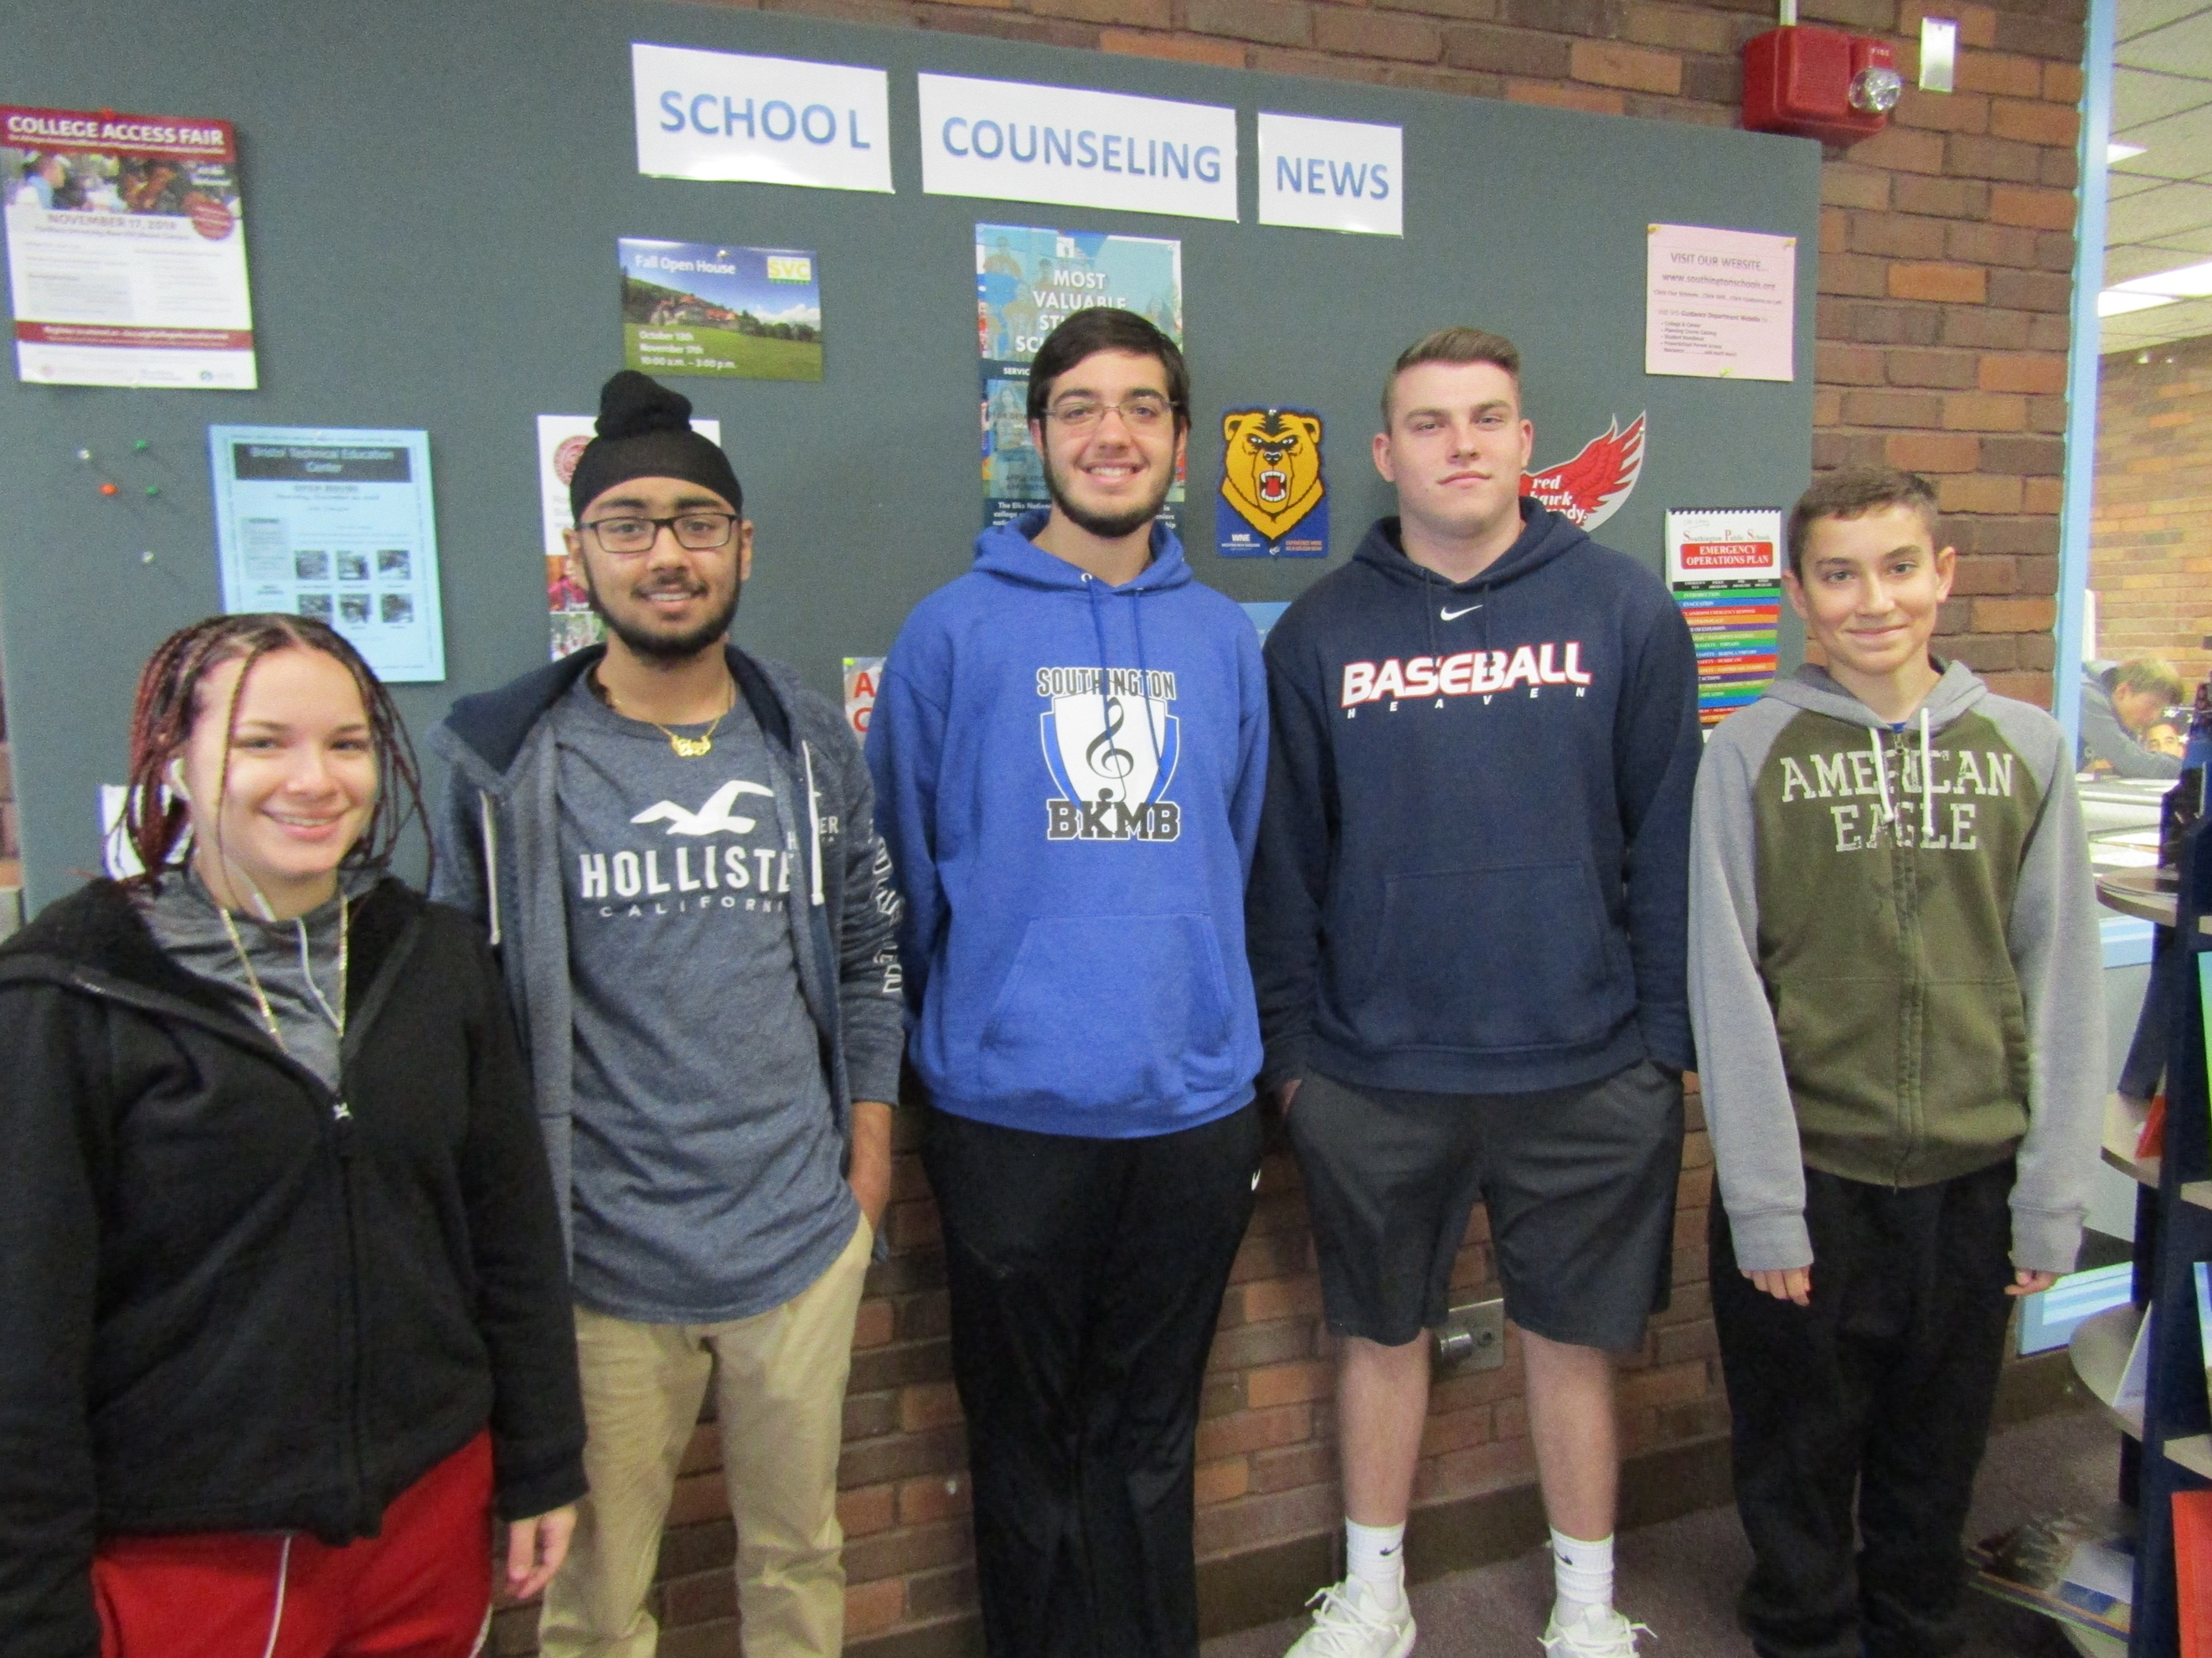
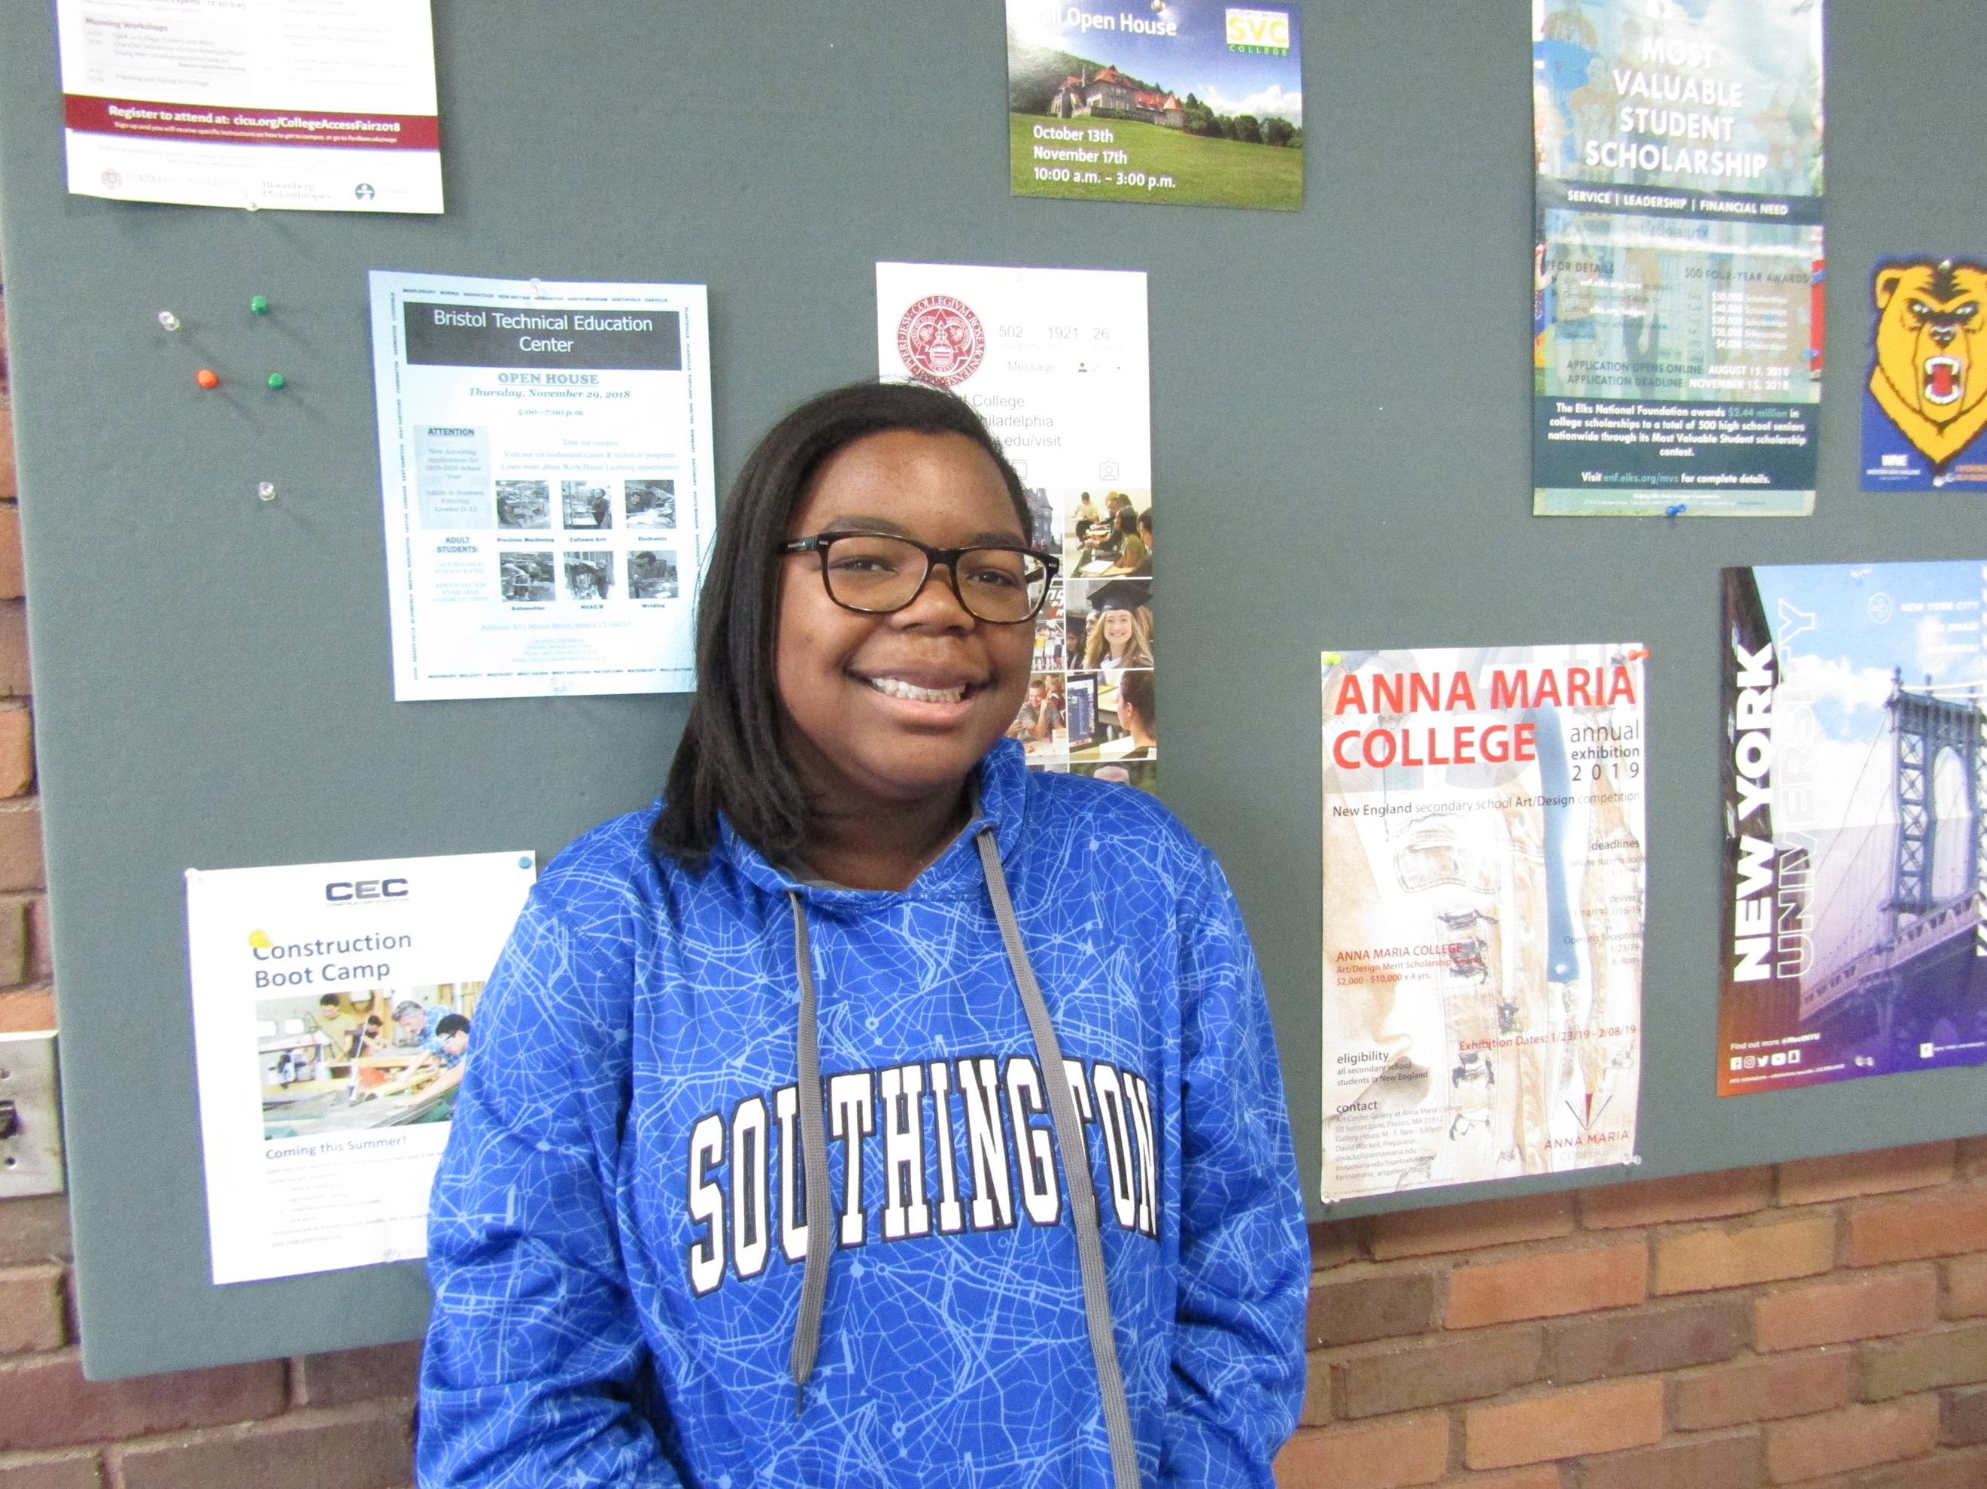
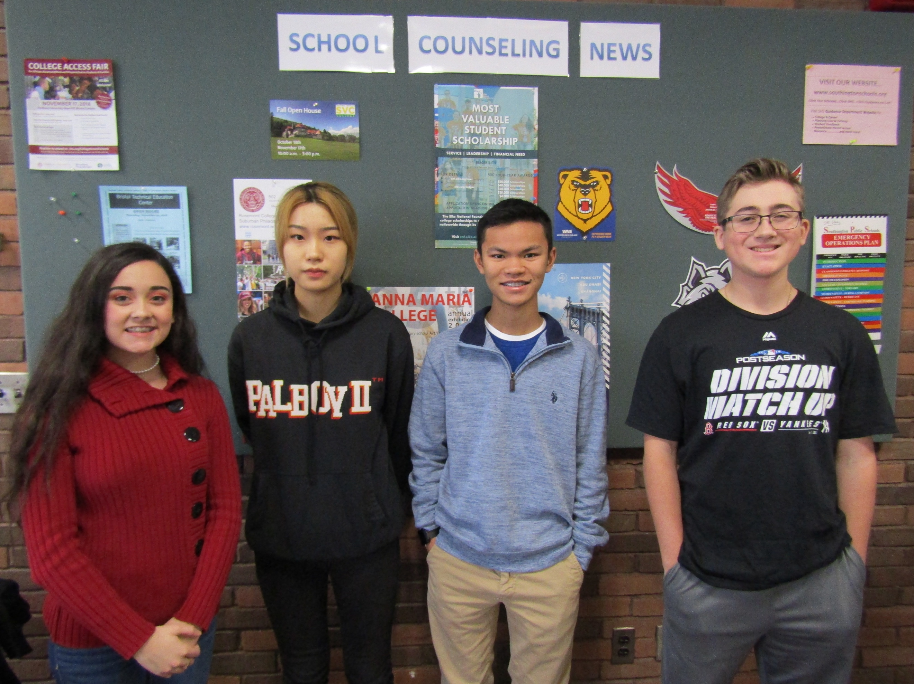
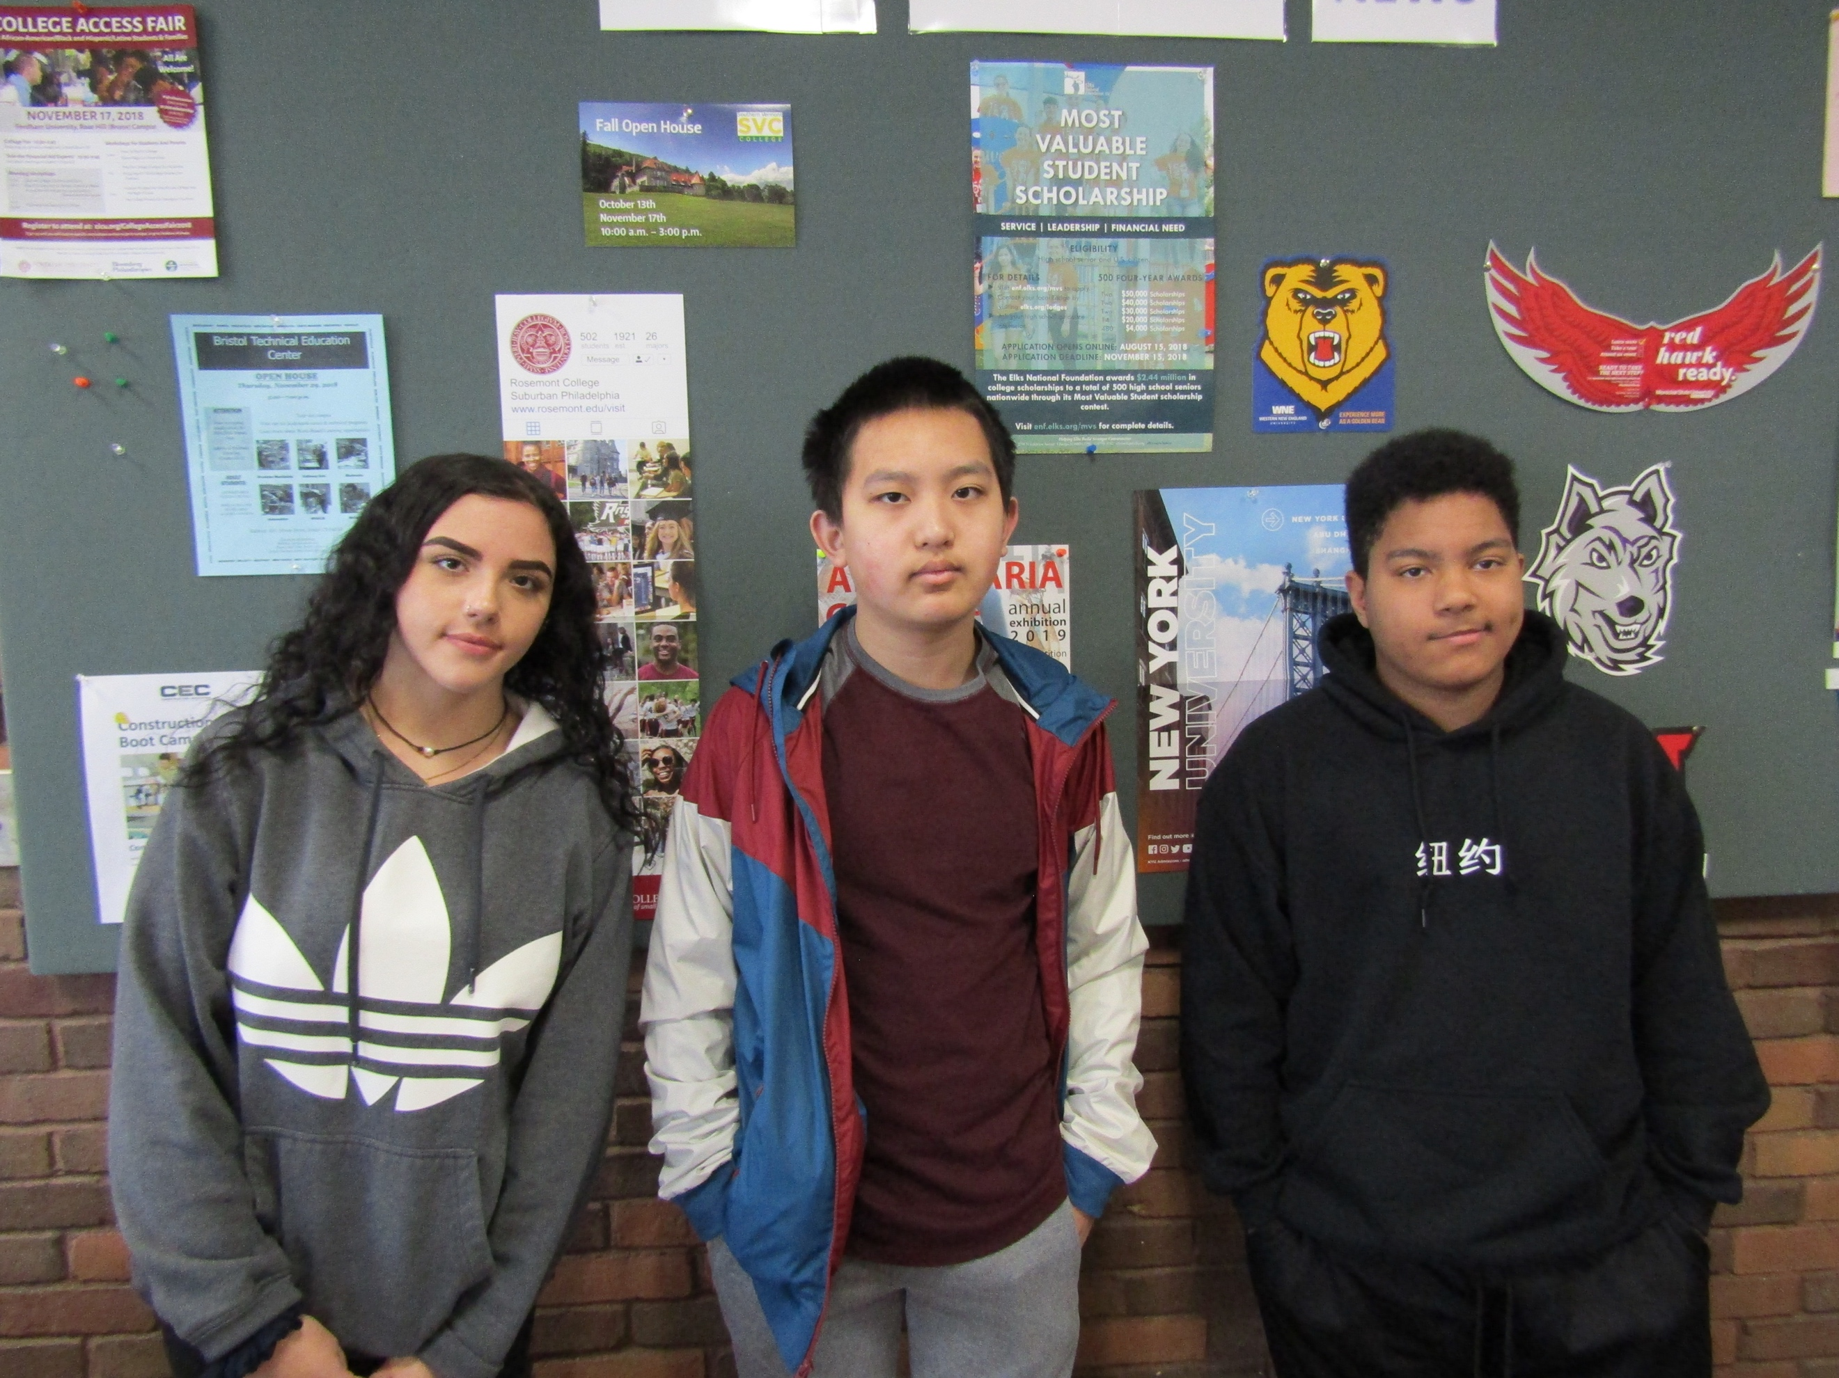
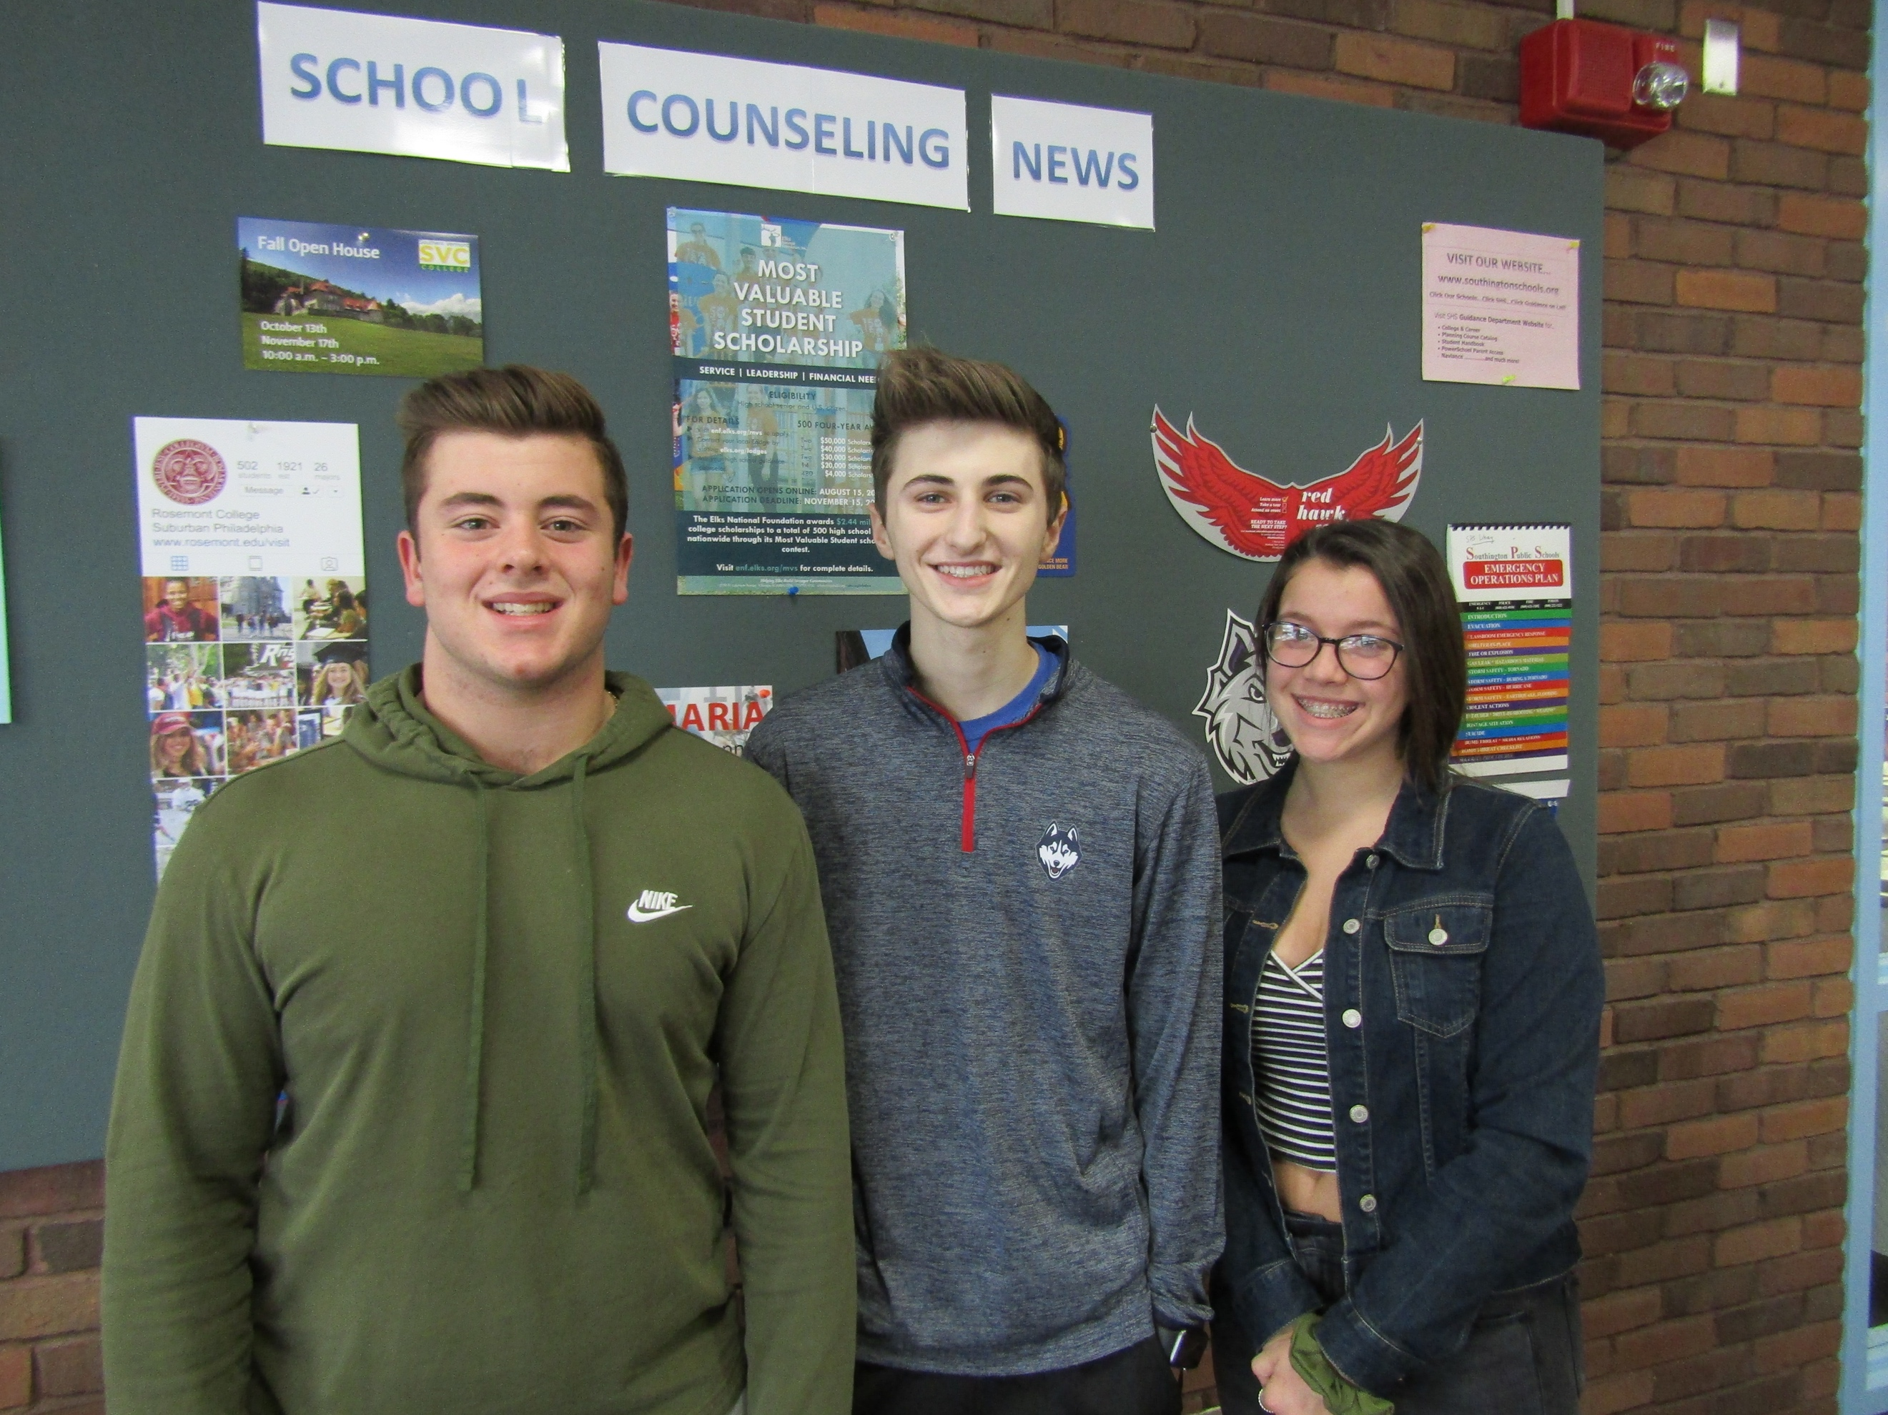
Jayleen Davila-Literacy, Gursahajpreet-Counseling and Support, Justin F-Music
Bryce F-Math, Josh L-Science
Angelina P-World Language, Jiancheng Zhang-Counseling and Support, Kevin L-Social Studies, Bobby L-Math
Alexa K-Art, Tom B-Family and Consumer Science, Tyler G-Tech & Engineering
Mackenzie L-Science
Jacob V-Language Arts, Josh M-Library
Kalli G-Business
Make My Day, November 2018
The following students were honored by their teachers for their good deeds in class

Southington High School
Helpful Tips
SHS Main phone number: 860-628-3229

WHOM DO I CALL IF. . .
- I have a question or comment about . . .
  - My son’s/daughter’s academic progress in class
  - Expectations of my son/daughter by a teacher
  - Treatment of my son/daughter by a teacher
  - Appropriateness or placement of my son/daughter in a current course
Answer: The teacher

- I have a question or comment about. . .
  - Curriculum or policy of a department
  - Consistency among different sections of a department
  - Answers a teacher has given my about expectations, placement or performance of my son or daughter
Answer: The Department Leader

DEPARTMENT LEADERS
Marion Stannard | Ag-Sci | mstannard@southingtonschools.org
Thomas Horanzy | Art | thoranzy@southingtonschools.org
Lillian Schena | Business and Finance Technology | lschena@southingtonschools.org
Mary-Lynn Osborn | Family and Consumer Sciences | mosborn@southingtonschools.org
Rebecca Migliaro | Language Arts | rmigliaro@southingtonschools.org
Robert Lasbury | Math | rlasbury@southingtonschools.org
Sara Ossias | Music | sossias@southingtonschools.org
Scott Ottochian | Physical Education and Health | sottochian@southingtonschools.org
Nicole Raccio | Science | nraccio@southingtonschools.org
Heather Allenback | Social Studies | hallenback@southingtonschools.org
Gail Lessard | Special Education | glessard@southingtonschools.org
Mary-Lynn Osborn | Technology and Engineering Education | mosborn@southingtonschools.org
Tina Riccio | World Language | triccio@southingtonschools.org

HEALTH SERVICES (860) 628-3229 ext. 11255
Jean Griglun, R. N.
Lisa Meccariello, L.P.N.
Zoe Backus, L.P.N.

- I have a question or comment about. . .
  - Disciplining my son/daughter
  - An answer a teacher has given me about treatment of my son/daughter
  - An answer a department leader has given me about the performance or expectations of my son/daughter
Answer: The Assistant principals
Richard Aroian | raroian@southingtonschools.org | (860) 628-3229 ext. 11380
Michael Halloran | Mhalloran@southingtonschools.org | (860) 628-3229 ext. 11229
Dianne Holst-Grubbe | dholstgrubbe@southingtonschools.org | (860) 628-3229 ext. 11230
Jeff Shaw | jshaw@southingtonschools.org | (860) 628-3229 ext. 11433

- I have a question or comment about. . .
  - Post high school planning for my son/daughter
  - Course selections for the following year
  - General concerns about my son’s/daughter’s overall performance/behavior
  - Answers from teachers or department leaders regarding current placement of my son/daughter
Answer: The School Counselor 860-628-3229 ext. 11238 or ext. 11244

Jen Discenza, Director | jdiscenza@southingtonschools.org
Mark Bugnacki | mbugnacki@southingtonschools.org
Jessica Anthony | janthony@southingtonschools.org
Mark Hill (ALTA) | mhill@southingtonschools.org
Geoffrey Davis | gdavis@southingtonschools.org
Ana Napolitano | anapolitano@southingtonschools.org
Sherry Russman | srussman@southingtonschools.org
David Gleba | dgleba@southingtonschools.org
Jessica Wallace | jwallace@southingtonschools.org
Beth Viens | bviens@southingtonschools.org

- I am dissatisfied with answers I have received from other school personnel or I have a question or comment about school policy. . .
Answer: The Principal, Brian Stranieri

If you are not sure who can help you, call the school office and your call will be referred to the appropriate person. You should expect a call back within two school days from any person on this list. To email any faculty member: first initiallastname@southingtonschools.org. For example, Brian Stranieri would be bstranieri@southingtonschools.org.

Regular Day |  | HR Day |  | Early Dismissal |  | 2 Hour Delay
Warning Bell 1 | 7:32 | Warning Bell 1 | 7:32 | Warning Bell 1 | 7:32 | Warning Bell 1 | 9:32
Warning Bell 2 | 7:36 | Warning Bell 2 | 7:36 | Warning Bell 2 | 7:36 | Warning Bell 2 | 9:36
 |  | HR | 7:37-7:42
1 | 7:37-8:25 | 1 | 7:46-8:31 | 1 | 7:37-8:10 | 1 | 9:37-10:10
2 | 8:29-9:15 | 2 | 8:35-9:20 | 2 | 8:14-8:45 | 2 | 10:14-10:45
3 | 9:19-10:05 | 3 | 9:24-10:09 | 3 | 8:49-9:20 | 3 | 10:49-11:20
4 | 10:09-10:55 | 4 | 10:13-10:58 | 4 | 9:24-9:55 | 4 | 11:24-11:55
5 | 10:59-11:45 | 5 | 11:02-11:47 | 5 | 9:59-10:30 | 5 | 11:59-12:30
6 | 11:49-12:35 | 6 | 11:51-12:36 | 6 | 10:34-11:05 | 6 | 12:34-1:05
7 | 12:39-1:25 | 7 | 12:40-1:25 | 7 | 11:09-11:40 | 7 | 1:09-1:40
8 | 1:29-2:15 | 8 | 1:30-2:15 | 8 | 11:44-12:15 | 8 | 1:44-2:15

Attendance Policy

The administration has established attendance regulations which reflects that time lost from class is essentially irretrievable in terms of opportunity for instructional exchange; that excessive absences rob teachers and students of instructional time that could be better spent on programs and activities; and that a student has an obligation to give, as well as receive, in the context of the classroom setting. Attendance for Southington High School students follows the Southington High School Handbook requirements.

All regulations below are to ensure compliance with Board of Education Policy 5113 and align with the beliefs and values of the Southington Board of Education.

Notifying the School of Absences
When a student is absent, the student’s parent/guardian should contact the school in the morning (by 10:00 a.m.) of the day of the student’s absence by telephoning 628-3229 (Ext. 389). The attendance office is equipped with 24-hour voice mail. If there is no answer, please leave a message with the student’s name, grade, and reason for absence.

Definitions
The following is a listing of definitions pursuant to this regulation.
- "Absence" is when a student in grades 9-12 is absent from an entire day or class or school with or without parental or guardian permission.
A student is considered to be "in attendance" if present at his/her assigned school, or an activity sponsored by the school (e.g., field trip), for at least half of the regular school day. A student who is serving an out-of-school suspension or expulsion should always be considered absent.

2. "Excused Absence" include absences from school for absences one through nine, and appropriate documentation is provided by the student's parent/ guardian approving the absence, due to
- Illness or injury (with doctor’s verification after the tenth absence and all subsequent absences thereafter)
- Death in the family
- Religious holidays
- Court appearances
- Lack of transportation that is normally provided by a district other than the one the students attends (This reason does not require documentation and does not apply to exclusion from transportation for disciplinary reasons.)
- Limited absence from school for special activities or extraordinary educational opportunities with parental or guardian consent, subject to the advance approval of the Principal or his/her designee, in accordance with SDE guidelines.

3. For the tenth absence and all others thereafter, the same reasons cited above shall constitute "excused" absences. Documentation by a medical professional is required for illness, regardless of the length of the absence.
The administration will determine whether absences are excused or unexcused. The school does not consider all absences from class or school which have been explained by parents/guardians to be excused. However, for purposes of the reporting of truancy to the SDE, the state approved definitions of "excused" and "unexcused" absences will be used. The District is not precluded from using separate definitions on such absences for its internal uses.
Students who have been absent from school must turn in a note from a parent/guardian or have a parent/guardian call to explain the student's absence if it is to be considered excused; otherwise it will be treated as an unexcused absence

4. "Unexcused Absence" is an absence from any entire regularly scheduled school day for which the absence is not excused as defined above. A student's absence shall be considered unexcused unless the absence meets the definition of an excused absence,
17
listed above, including the fulfillment of the documentation requirements, or if an absence is the result of school or District disciplinary action.

5. “Chronically absent child” is an enrolled student whose total number of absences at any time during a school year is equal to or greater than ten percent of the total number of days that such student has been enrolled at such school during such school year. *(See District Truancy Committee in Student Handbook available online at www.southingtonschools.org)

6. “Absence” means an excused absence, unexcused absence or disciplinary absence, as those terms are defined by the State Board of Education or an in-school suspension that is greater than or equal to one-half of a school day.

7. “District chronic absenteeism rate” means the total number of chronically absent children in the previous school year divided by the total number of children under the jurisdiction of the Board of Education for such school year.

8. “School chronic absenteeism rate” means the total number of chronically absent children for a school in the previous school year divided by the total number of children enrolled in such school for such school year.

9. A "Class Cut" occurs when a student misses a class and has no legitimate reason for doing so or is tardy to or leaves school and does not have a legitimate excuse.

10. "Tardiness" occurs when a student arrives at school later than the beginning of school. A parent/guardian may explain tardiness, but any resulting absence will be considered as an accumulated absence and the student may lose credit. Students tardy to school are responsible for work done in classes missed as well as assignments given or due.
11. A "Truant" is any student who has four (4) unexcused absences from school in any one month or ten (10) unexcused absences from school in any school year.

12. A "Habitual Truant" is any student who has twenty (20) unexcused absences within a school year.

The high school staff considers classroom attendance to be an integral part of a student’s course of study. Any student who exceeds the maximum number of allowable absences for a course and is unable to justify those absences will lose credit for the course.
Absences and tardiness become part of the student’s permanent record which, many times, is requested by higher institutions and potential employers. Therefore, punctual and regular attendance is extremely important. Every attempt should be made to confine necessary appointments to after school hours and vacation periods. In order to take advantage of special services (such as the collection of homework assignments for the student who must be out for several days), parents are advised to keep the school informed of their child’s health status. In cases of prolonged or regular illness, a note from a physician should be sent to the school explaining the nature of the illness.

Southington High School has an Attendance Policy which states that classroom attendance is an integral part of the student’s course of study. The following are its standards:
1. COURSE CREDIT
To earn credit in any course a student is obligated to
A. Fulfill the course requirements as established by the teacher.
B. Earn a minimum grade of 60.
C. Fulfill attendance requirements as established by the school.
2. ATTENDANCE STANDARDS
A. When a student is absent, the student’s parent/guardian should contact the school in the morning (by 10:00 a.m.) of the day of the student’s absence by telephoning 628-3229 (Ext. 389). The attendance office is equipped with 24-hour voice mail. If there is no answer, please leave a message with the student’s name, grade, and reason for absence.
B. The maximum number of absences allowed in any half-year course is nine (9) days from school or from class.
The maximum number of absences allowed in all full-year courses is seventeen (17) days from school or from class.
D. Students who exceed the maximum number of absences allowed will lose credit in the course unless an extension has been granted by the Academic Credit Office.

3. EXCUSED ABSENCES
A student’s absence from school shall be considered excused if written documentation of the reason for the absence has been submitted within ten school days of the student’s return to school (CGS Section 10-210) and meets the following:
- For absences one through nine, a parent approves such absence and submits appropriate
documentation; and
- For the tenth absence and all absences thereafter, a student’s absences from school are
considered excused for the following reasons:

1. Illness of the student (Note: all student illness absences from school must be verified
by an appropriately licensed medical professional to be deemed excused, regardless of
length of absence).
2. Student’s observance of a religious holiday.
3. Death in the family or other emergency beyond control of the student’s family.
4. Mandated court appearance.
5. The lack of transportation that is normally provided by a district other than the one the
student attends (no parental documentation is required for this reason).
6. Extraordinary educational opportunities pre-approved by district administrators and in
accordance with Connecticut State Department of Education guidance. 7. Other valid reasons as determined by a school administrator.

The determination of whether an absence is excused will be made by the building principal, or his designee.
Student Absences Due to Communicable Diseases
We want only well students in school and will exclude those who are not well. All exclusions are made through the school nurse, and an explanation for the exclusion will be given to the parent either by telephone or by personal contact at the time of exclusion.
Students who have been absent because of the following communicable diseases will be required to obtain a medical re-admission slip from the Southington Director of Health:
Bacterial Meningitis Poliomyelitis
Diphtheria and Carriers Small Pox
Encephalitis
Students who have been absent because of the communicable diseases listed below may be readmitted with a note from their own physician.
German Measles (Rubella) Pertussis (Whooping Cough)
Impetigo Ringworm (scalp or body)
Infectious Hepatitis Tuberculosis
Measles (Rubeola) Viral Meningitis
Mumps
Students who have been absent because of the communicable diseases listed below may be readmitted by the nurse with a note from their parent/guardian or physician stating the disease and dates of absence.
Chicken Pox (Varicella) Pediculosis (head or body lice)
Conjunctivitis (Pink Eye) Scabies
Mononucleosis Streptococcal Infections (respiratory)

All pupils readmitted to school with any of the above diseases are to be referred to the school nurse upon return to school.

4. UNEXCUSED ABSENCE
A student’s absence from school shall be considered unexcused unless they meet one of the following criteria:
- absence meets the definition for an excused absence (including documentation
requirements)
- the absence meets the definition of a disciplinary absence.

CLASS CUT (Counts as an unexcused absence)
A Class Cut is an absence of 10 or more minutes from a class without permission.

- CONSEQUENCE FOR CUTS
A student who has two class cuts in any course will lose credit at the time of the second cut regardless of the number of excused absences in that course.

Truancy Policy
The Board of Education recognizes the importance of early intervention for students exhibiting truancy behavior. Connecticut State Statute Section 10-198a defines a “truant” as a student aged 5–18 who has four (4) unexcused absences in one month, or ten (10) unexcused absences in a year. A “habitual truant” means any student, aged 5–18, who has twenty (20) unexcused absences within a school year.

Please review the SHS Student Handbook found on the main SHS page for more information about unexcused and excused absences.

Early Dismissal
Early dismissal is only for grade 12 students. Students on early dismissal must leave the building at the specified time and may not re-enter the building before 2:15 PM.

Leaving Early
Only students with administrative permission may leave school early. A student who needs to leave school early for a necessary appointment must bring a note from a parent to the attendance officer BEFORE school (7:37 a.m.). The attendance officer may call the parent to verify the note and, if the appointment is deemed necessary for school hours, an early dismissal pass will be issued to the student. Any student leaving during the day for an appointment must present a note upon returning to school. If a note is not presented upon the return to school or within THREE school days, it will be considered a cut to the classes the student missed while signed out. In addition, STUDENTS MUST SIGN OUT IN THE ATTENDANCE OFFICE BEFORE LEAVING THE SCHOOL BUILDING.

SHS is a closed campus. Students are required to remain on campus all day, including the lunch periods and study halls. Students are not to go to their vehicles unless they get a pass. Students in violation of this policy may lose privileges such as parking privileges and will receive school consequences.

Due to student safety concerns as well as company regulations, the Southington school district does not condone or allow private transportation companies such as Uber or Lyft to transport students home from school without being accompanied by a parent or guardian.

SCHOOL COUNSELING
The Southington Public School’s Comprehensive Counseling Program, which is an integral part of the total educational process, is designed to address the developmental needs of all students. Through a planned and sequential program, each student will develop his/her individual potential in the areas of academic, personal/social, and career development. Respectful of individual differences, the program assists and supports students as they begin to understand themselves, develop decision making and problem-solving skills, and plan for the future. Counselors function in a number of different capacities: counselor, consultant, teacher, manager and role model. Counselors work as a team in conjunction with teachers, administrators, parents, and the community to assist students to be successful academically, and to develop into productive members of society. All students have an assigned school counselor. To see your counselor, come to the main Counseling Office (Ninth Grade Academy Office for grade 9) and you will have access to sign up for an appointment electronically on devices or seek assistance from either of the school counseling secretaries.

Naviance
Every Southington High School student will develop a Transition Portfolio with school counselor assistance. The Naviance Family Connection tool is a web-based program (http://connection.naviance.com/southington) that is being used at SHS to assist students/parents and counselors when developing a transition portfolio.

Student Success Plans
State of Connecticut Public Act No. 11-135 “For the school year commencing July 1, 2012, and each school year thereafter, each local and regional board of education shall create a student success plan for each student enrolled in a public school, beginning in grade six. Such student success plan shall include a student’s career and academic choices in grades six to twelve, inclusive.”

Working Papers
Do you have a job? If so, the Connecticut State Department of Labor requires students under the age of 18 years to obtain working papers to prove eligibility for employment. Working papers are issued by the school counseling secretaries, the designated agents for the Superintendent. Students need to come in person and bring a written “Promise of Employment” from the employer providing work. A Promise of employment must be written on the employer’s letterhead and must include the following: · The specific job that the individual will be performing · Starting rate – CT minimum wage · Number of hours per week · Signature of the authorized company official. The Promise of Employment must be dropped off in the school counseling office before first period and the completed working papers can be picked up at the end of that day.

IMPORTANT DATES FOR 2018-2019
To Remember throughout the School Year

December 1-SHS Fall Drama performance
December 19-SHS Winter concerts
December 20-SHS winter concerts (snow date)
December 21-Holiday recess begins
January. 3-School resumes
January 9-Course Fair
January 16-Course Fair-Snow day
January 15-Early Dismissal-PD
January 16- Martin Luther King Day-No School
January 22-25-Midterm Exams
January 25-Quarter 2 ends
February 12-Navigating the College Process
February 15-Professional Development-Early dismissal
February 19-Professional Development-No School
February 20-Snow date for Navigating the College Process
March 1-Surround Sound
March 2-Surround Sound
March 15-SHS Spring Drama Performance
March 16-SHS Spring Drama Performance
March 20-World Language Induction Ceremony
March 22-SHS Unified Theater show
March 26-Professional Development-Early Dismissal
March 29-End of Quarter 3
April 6-SHS Junior Prom
April 9-SAT in School testing Juniors only
April 15-19-Spring break
April 22-Classes resume
April 23-Professional Development-Early dismissal
April 30-SHS Spring Concert (Band and Orchestra)
May 1-SHS Spring Concert (Chorus and Jazz)
May 2-SHS NHS Induction Ceremony
May 8-SHS Academic Awards Night
May 13-SHS Art Show opening night
May 14-Professional Development-Early dismissal
May 18-SHS Senior Prom
May 22-SHS PTLW Senior Night
May 28-Freshman Orientation (Clubs and Activities)
May 27-No School-Memorial Day
May 30-Class Night
May 31-Class Day
End of year dates:
June 5-10 SHS Final Exams
June 11-Projected last day of school/Graduation

SHS STUDENT HANDBOOK
The Student handbook explains the rules of our school and other important information. Students and parents can find the student handbook on the main page of the Southington High School website.

SHS SATURDAY SAT TESTING DATES FOR 2018-2019
Registration information for SATs is also available online at www.collegeboard.com.

Scheduled Test Date: March 09, 2019
Scheduled Test Date: June 01, 2019

In-School SAT Day will take place on Tuesday, April 9,, 2019.

CLASS ADVISORS
Class advisors assist students with planning many activities during the students years at SHS including Jr. Prom, Class Day/Night and Senior prom. Below are the class advisors for each class and their email addresses
Class of 2019
Sara Adams (sadams@southingtonschools.org) and Holly Jayne (hjayne@southingtonschools.org)
Class of 2020
Colleen Murphy (cmurphy@southingtonschools.org) and Nicole Proffitt (nproffitt@southingtonschools.org)
Class of 2021
Megan Martin (mmartin@southingtonschools.org) and Teresa Garrity (tgarrity@southingtonschools.org)
Class of 2022
Kristin Bellis (kbellis@southingtonschools.org) and Katie Tavera (ktavera@southingtonschools.org)

CELL PHONE AND ELECTRONIC DEVICES POLICY
Electronic Devices Possession or use of laser pointers by students on school grounds is not allowed. In addition, no student may record, photograph, or videotape within the school setting without prior permission from a teacher or administrator.

From 7:37 AM to 2:15 PM cell phones and other electronic devices are restricted to the cafeteria, media center or in the hallways during passing time. All devices must be put away, and out of sight, before a student enters a classroom. Within the classrooms, electronic devices may be used for teacher directed educational purposes only. For safety reasons students must be able to hear the public-address system at all times. Ear bud usage is prohibited in the hallway, lavatories and stairwells. Head phones are prohibited at all times.

Any student who is found to be in violation of these rules will be referred to the main office.

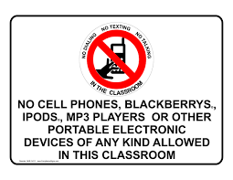

INTERNET USE / SOCIAL NETWORKING
Students must comply with Board of Education Policy regarding computer and internet use, social networking as well as any other procedures established by the classroom teacher and/or Southington High School Technology Department. Inappropriate use or failure to comply with any teacher’s instructions related to the use of computers may result in a disciplinary response/consequence, including loss of user privileges.

PARENTAL RIGHTS REGARDING INTERNET POSTING OF STUDENT’S NAMES AND IMAGES
Students in kindergarten through grade twelve, staff assigned to the grade levels, and others authorized to work with these students (who have school-sponsored access to the Internet) will not make available on the Internet the addresses or phone numbers of students. Student names, or altered versions of student names, the schools to which they are assigned, grade level assignments, or pictures of students may be made available unless parents have objected in writing to such a release for their child or children. The Internet is a valuable research tool and is widely used as a resource of communication for students, staff, and parents. Internet access by students is guided by Board of Education regulations and monitored on site by staff. Access to the Internet for research purposes and as a vehicle of communication may, from time to time, result in the release of certain information. Typically, the information is minimal in content and consistent with what is readily available through other media sources such as newspapers, television, and radio. Where feasible, every attempt is made to limit the release of information over the Internet to student names or preferably altered versions of student names, the schools, grade levels and images of students. The release of student phone numbers and home addresses is prohibited. (If you object to the release of any of the above information as it relates to your son/daughter, you must notify the building principal in writing at the beginning of each school year.)

DRESS CODE
Each student in the Southington Public Schools has the responsibility of dressing in appropriate attire with respect to neatness, decency, modesty, health, and safety. Through their dress, students will demonstrate respect for themselves, their fellow students, and for the educational process. When choosing a student’s outfit for school, students and parents should keep in mind that their choice of clothing can affect the learning environment and will be judged along more formal rather than informal guidelines. For all students, exposed upper thigh (shorts or skirts should be no shorter than fingertip length when arms are at students’ sides), navel, stomach, lower back, or chest are inappropriate and not allowed. In addition, clothing meant to be worn as an undergarment (including spaghetti straps) should not be worn as an outer garment. Shirts should have straps at least three fingers wide so that no undergarments are shown at any time. All clothing shall be worn in a manner that does not expose underwear. In addition, at no time will tops be allowed which expose a bare midriff, rib cage, or undergarments.

For all students:
- The length of shorts and skirts should have a (recommended) minimum 5 inch inseam/hemline (no shorter than fingertip length when arms are at student’s sides - see images below). Slits, cutouts, rips and transparent material above this line are not permitted.
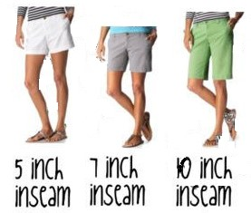

Clothing with offensive language, messages, or illustrations is not allowed. The term offensive includes, but is not limited to, any wording or symbols that advertise or promote the imagery of alcohol, tobacco, or other drugs, or which debase or negatively portray any individual or group through cultural, political, racial, religious, sexual, or other innuendo. Also included are types of clothing that contain weapons, violence, hate, or death messages.
All students who are sent for a review of their outfit must report to the Main or Ninth Grade Academy office immediately. The administration will decide if the outfit is in compliance with the spirit of the dress code and make the final determination regarding whether the student may return to class or needs to change into more appropriate apparel.
The Board of Education requires students to dress in clothing appropriate to the school setting and which is conducive to teaching and learning.

Restrictions on freedom of student dress may be applied whenever the mode of dress in question:
1. is unsafe for the student or those around the student;
2. is disruptive to school operations and the education process in general;
3. is contrary to law.

No restrictions on freedom of dress and adornment will be imposed which:
1. reflect discrimination as to civil rights;
2. enforce particular religious’ tenets;
3. do not fall within the direct or implied powers of the Board of Education.

The Board of Education has addressed the specific issue of hats in the schools:

1. At the discretion of the principal, hats may be worn in the school setting, but not in individual classrooms;
2. Two exceptions to the classroom limitation are allowed.
a. When hats are required for curricular or verified medical reasons;
b. When hats are worn to school as part of a special “hat day” event as approved by the principal.
Pursuant to this policy, the high school administration has established the following regulation regarding head coverings: Hats, bandanas, headbands, and any other head covering must be kept out of sight and not be worn in school after 7:37 AM and before 2:15 PM. Repeated offenses will result in a disciplinary consequence.

HEALTH AND SAFETY:
Any medication, either prescription or “over-the-counter,” which needs to be administered to a student during the school day must first be delivered directly to the health office in the original labeled container by a parent, guardian, or other responsible adult. An official form will need to be completed by the parent and physician. Speak to the nurse, in advance, for specific details about compliance with Board of Education policy.

During any emergency or drill (fire, lockdown, secure school or shelter in place), all students must follow the directions of any school employee or other person(s) in charge.

No student shall bring to school, keep or store in an area, any item which endangers the health, safety, or welfare of members of the school community.

Student use, possession, and/or distribution of tobacco products or facsimile, including e-cigarettes or vapes, is banned at any time on school property or at any school activity.

Students must keep their Identification Card on their persons at all times during the school day. They must also present it to staff upon request.

Hazing/Bullying will not be tolerated among students of the school district.

Sexual harassment will not be tolerated among students of the school district. (Refer to pages 25-26 in the student handbook.)

Students from other schools are not permitted in the building or on school grounds during the school day without prior administrative approval.

SCHOOL NURSE INFORMATION
The school nurses are located on the main floor between the Counseling Office and the main cafeteria. The nurses are available to accommodate students for first aid or illness. The nurses are also available to students on a consultation basis when requested.

The role of the school nurse is restricted to providing basic health care for students as mandated by the law. The nurse is responsible for several types of health screenings, routine health checks, parent contact concerning health related issues, care of minor illness or injuries occurring during the school day, administration of medications under a doctor’s orders, maintenance of student health records, infectious disease control, promotion of good health practices, counseling and education. While nurses may respond to minor illnesses or injuries which occur during the school day, they are not considered primary care givers. School nurses may not diagnose or prescribe treatment or medication for illnesses or injuries of any kind.

For physical forms, sports forms and other useful information and links to excellent resources, please visit both our Health Services page on SHS website and the district’s health services pages found in the Central Office tab.

CAFETERIA NEWS
Lunch prices for SHS students are $3.25 per meal for 2018-2019 school year. Breakfast prices are $2.00 per meal. For helpful links on how to put money on your child’s account, applying for free/reduced breakfast/lunch and more please visit the Southington Public Schools district website and select the Parents and Students tab. If you have further questions, feel free to contact Nya Welinsky at nwelinsky@southingtonschools.org.

YEARBOOK NEWS

Please note that only photos from Art Rich will be accepted for publishing in the yearbook. Photos from other photographers cannot be used in the yearbook.
For more information about the yearbook-deadlines for submissions, cost and more, please visit the Southington High School website and select the Chronicle/Yearbook page within the Student Life section or on our main webpage in the Student section.

POWERSCHOOL-
Powerschool is a program that will enable you and your child to gain quick access to his or her attendance and progress in classes, as well as other helpful information. It is important that students log in with their own student username, not their parents username.
Here are the directions for gaining access to that program:

- Open your internet browser
- Go to https://ps.southingtonschools.org/public/...
- Put in your username and password. Click Sign in.
Here is a brief list of the functions you may gain access to:
- Grades and Attendance
- Attendance history
- Email notifications
- Teacher comments
MEDIA CENTER
The media center is located on the top floor of the high school. Keeping in mind the special guidelines found below, students may access the media center before or after school, during full period study halls and during their lunch periods. During the school day…

1. freshman students…
a. can access the library during a full period study hall or lunch period
b. must remain in the media center for the entire period
c. must sign in at the main desk when they arrive
2. sophomore, junior and senior students…
a. can access the media center during a study hall or a lunch period
b. must report to the media center at the start of the period
c. may leave the media center to go to the cafeteria at any time during the period but may not return to it later.
* *Those students who have a period 8 study hall must sign in when they arrive and remain there during the entire period.

Databases, a reliable source of information, have been purchased for students use. Both teachers and the library media staff encourage students to use the databases at home. Please ask the library media staff for the username and password to access remotely. We also encourage students to read for pleasure and have updated our print and eBooks collection to reflect students interests. We encourage students to share with us books that they have read during the summer or throughout the year.

PARTICIPATION IN ATHLETICS AND OTHER CO-CURRICULAR ACTIVITIES

Participation in athletics or co-curricular activities (previously referred to as extra-curricular activities) at Southington Public Schools is a privilege and demands certain commitments and responsibilities. The school system and community have a high level of expectations for the students who represent the schools. Therefore, it is expected that student athletes and participants in other co-curricular activities shall conform to the behavioral norms of the school, the rules and regulations established here and in the SHS Athletic Handbook and any other published or established rules or regulations applicable to a particular activity. The Southington Board of Education Policy and Administrative Regulation 5133 sets forth expectations related to student participation in Athletics and other Co-Curricular Activities. The Policy and Administrative Regulation relates to student behaviors both in and out of season and on and off school grounds. It includes examples of some but not all of the behaviors that could result in suspension or dismissal from an athletic team or co-curricular activity.

The following sports are among those available to Southington High School students:

Fall | Winter | Spring
Cheerleading | Basketball (Boys) | Baseball
Cross Country (Boys) | Basketball (Girls) | Golf (Boys and Girls)
Cross Country (Girls) | Cheerleading | Lacrosse (Boys)
Field Hockey (Girls) | Gymnastics (Girls) | Lacrosse (Girls)
Football | Indoor Track (Boys) | Softball
Soccer (Boys) | Indoor Track (Girls) | Tennis (Boys)
Soccer (Girls) | Swimming (Boys) | Tennis (Girls)
Swimming (Girls) | Wrestling | Track (Boys)
Volleyball (Girls) | Ice Hockey | Track (Girls)
 | Unified Sports | Volleyball (Boys)

CLUBS
There are over 35 clubs and activities offered at SHS. The list is updated annually, however, new clubs are formed throughout the year with administration’s approval. Listen to the morning announcements during period 1 or read the morning announcements online for meeting dates and times. For a complete listing of clubs and their advisors, refer to the student handbook found in multiple locations on the SHS website in the Student Life section.
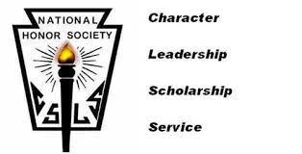

NON-DISCRIMINATION GRIEVANCE PROCEDURES
Any student, parent/guardian, staff member, or applicant to a program who feels discriminated against for any of the following reasons should address their complaint to the coordinators listed below.
Area of Concern | Legal Reference | Coordinator | Address | Telephone
Race, Color, National Origin | Title VI | Steve Madancy | Southington Public Schools  200 North Main Street  Southington, CT 06489 | 860-628-3200
Gender | Title IX | Amy Aresco/Erin Natrass | South End Elementary School  Maxwell Noble Drive  Plantsville, CT 06479 | 860-628-3320
Handicap/Disability | Section 504 | Margaret Walsh | Southington Public Schools  200 Main Street  Southington, CT 06489 | 860-628-3200
Sexual Orientation | State Statute 10-15-C | Steve Madancy | Southington Public Schools  200 Main Street  Southington, CT 06489 | 860-628-3200

PARENT/STUDENT TO DO LIST
- Read the Student/Parent Handbook.
- Please be sure you have signed into you PowerSchool account to update your demographic information.
- Have physical and immunization records on file with the nurse. Supply nurse with ALL medications that you must take during school time.
- Call the attendance office at 860-628-3229 ext. 11256 by 9:00 on any day your child is absent.

