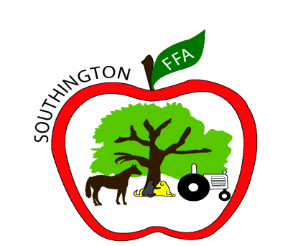
Director
Marion Stannard
Instructors
Brian Bostrom
Patrick O’Keefe
Nicole Hodges
Owen McLaughlin
Molly Stanavage
Secretary
Karen Barry
The Carl M. Small Regional Agriculture Center Southington High School
720 Pleasant Street ● Southington, CT 06489
Phone: (860) 628-3229 x11415
Fax: (860) 620-1687
Visit us at: www.Southingtonschools.org

Thank you for your interest in the Regional Agriculture Science and Technology Program!
Application due by December 15th

The following is a checklist to help you distribute the enclosed paperwork (10 pages total) to the appropriate person.

To be completed by student and parent (when all completed return packet to your school counselor’s office):

□ Pages 1, 2, 3, 4, 6 (page 6 parents signs), 10

School Counseling Office:

□Page 5 Information to be Completed by Sending School Form

□Page 6 Instructions for Release of Records (after parent signs and then forwards to school counseling office)

□Page 7 School Counseling Recommendation Form

Person of your choice (non-relative):

□Page 8 Personal Recommendation Form

Teacher of your choice:

□Page 9 Teacher Recommendation Form

