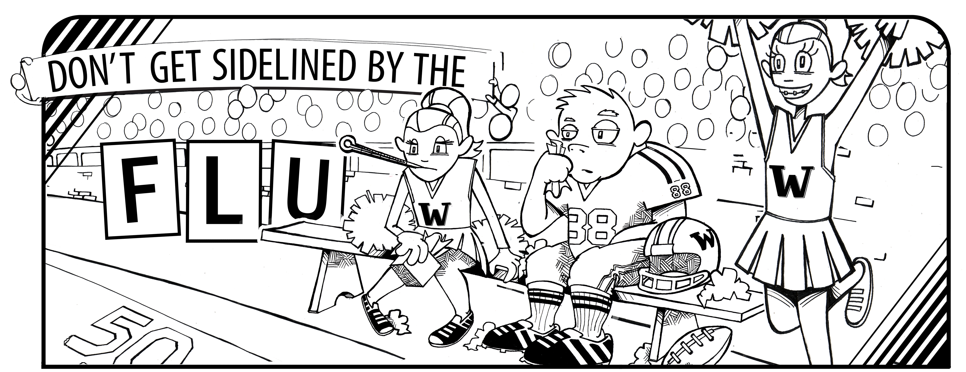


M S
FOR ADDITIONAL INFORMATION ON THE INFLUENZA VIRUS, VISIT WWW.CDC.GOV/FLU

This program is sponsored by the National Association of School Nurses (NASN) and supported by an educational grant from Roche.

- Vaccination: According to the Centers for Disease Control and Prevention (CDC), the best way to prevent flu is to get a vaccine. While October and November are the best times to get a flu vaccine, it’s never too late to get vaccinated. It takes about two weeks for the vaccine to become fully effective. There is plenty of vaccine still available, according to the CDC.

- Antiviral Medication: Prescription antiviral medication is an important adjunct to vaccination for flu prevention and treatment. If a child has been around someone who has the flu, a doctor can prescribe antiviral medication to help prevent the child from catching the virus. However, it’s important to contact the doctor fast, because children should begin taking the medication within the first 12-48 hours of exposure to the virus. If taken within that window of time, there is an 89 percent chance that antiviral medication will keep him/her from getting sick. A doctor can also prescribe antivirals to treat the flu, helping both adults and children feel better faster.

- Good Hygiene: Practicing good hygiene habits is a great way to help control the spread of germs like the flu virus. Parents should teach their children healthy habits such as:

- Washing their hands with soap and warm water for at least 20 seconds
- Covering their mouths and noses with tissues when sneezing and coughing
- Avoid sharing drinks, water bottles, silverware and pencils

The CDC suggests that parents disinfect objects frequently-touched by children, such as toys. Parents should also keep children who have influenza at home. For more information, see the fact sheet “When Sickness Strikes.”

Teachers, staff, and parents can help slow the spread of flu by serving as role models for good hygiene practices.

Controlling Influenza Among Children:
A 1-2-3 Approach

With flu season here, many parents across the country are finding themselves caring for children who are sick with influenza. Children are two to three times more likely than adults to get sick with the flu, and on average, one in three children in the U.S. is affected by the virus each year. The National Association of School Nurses (NASN) is working to educate parents about how they can keep their children healthy this flu season. Following is a simple three-step approach to flu prevention.

