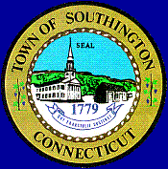
SOUTHINGTON PUBLIC SCHOOLS
PAY DATE SCHEDULE
2017 – 2018

July 7, 2017 January 5, 2018

July 21, 2017 January 19, 2018

August 4, 2017 February 2, 2018

August 18, 2017 February 16, 2018

√ September 1, 2017 March 2, 2018

September 15, 2017 March 16, 2018

September 29, 2017 March 30, 2018

October 13, 2017 April 13, 2018

October 27, 2017 April 27, 2018

November 9, 2017 May 11, 2018

November 24, 2017 May 25, 2018

December 8, 2017 June 8, 2018

December 22, 2017 June 22, 2018**

……………………………………………………………………………………………………………..

√ First Pay for Teachers, Para, Secretary 191 & 212, Nurses, ABA Therapists
** Teachers, Para Educators, Secretary 191 and 212, Nurses, ABA Therapist, 22nd pay or
Balloon Check (26 pays)

